Abstract

Trust Shield – Safety & Smart Emergency Assistance Website is a comprehensive web-based safety platform designed to provide real-time protection and emergency support for individuals, especially women, children, and travelers. The system acts as a digital safety companion by integrating emergency communication, live location tracking, incident reporting, and preventive safety tools into a single, user-friendly platform.
In emergency situations, users can activate a one-click SOS alert that instantly notifies predefined emergency contacts with the user’s real-time GPS location. The platform supports journey tracking to monitor safe travel, safe route recommendations, and danger zone mapping to reduce exposure to unsafe areas. Trust Shield also enables users to submit crime and incident reports, generate police complaint PDFs, and upload evidence such as images, videos, or voice recordings to strengthen incident documentation.
Additional features include fake call assistance for escape situations, quick text-based incident alerts, self-defense tutorials, period and health tracking, and a Missing Person Information Board to assist in community-based alerts. The system further enhances safety by providing access to nearby hospitals and police stations, travel safety guidance, and optional AI/ML-based risk analysis for future enhancements.
By combining modern web technologies, GPS services, and emergency alert mechanisms, Trust Shield aims to improve personal safety, reduce response time during emergencies, and empower users with preventive and reactive safety tools. The platform is designed to be scalable, reliable, and accessible, making it an effective solution for real-world safety challenges.

Requirement specification

The Trust Shield system requires both functional and non-functional components to operate as a complete safety and emergency assistance platform. The system must support user registration and secure authentication to ensure that only authorized users can access safety services. Users should be able to store personal details and manage a list of trusted emergency contacts who will receive alerts during emergencies.
The platform must provide a one-click SOS mechanism that instantly sends alerts along with the user’s real-time location. Continuous location tracking is required to support journey monitoring and safe travel features. The system should allow users to report incidents and crimes digitally, along with the capability to upload supporting evidence such as images, videos, or audio recordings. To assist legal procedures, the system should automatically generate police complaint documents in PDF format.
The application must integrate location-based services to display safe routes, danger zones, and nearby emergency facilities such as hospitals and police stations. Real-time communication services such as SMS, email, or in-app notifications are required to ensure timely delivery of emergency alerts. Additional features like fake call assistance, quick text alerts, self-defense guidance, and missing person information management should also be supported.
From a non-functional perspective, the system must ensure high reliability, fast response time, and secure data handling. User data and evidence files should be stored securely with proper access control to maintain privacy. The application should be user-friendly, accessible across multiple devices and browsers, and scalable to accommodate future enhancements such as AI/ML-based safety analysis. A stable internet connection and standard computing devices are required to operate the system effectively.

Software specification requirement

The Trust Shield system requires a stable software environment to support its safety and emergency assistance features. The application is designed to run on commonly used operating systems such as Windows, Linux, and macOS. A modern web browser like Google Chrome, Mozilla Firefox, or Microsoft Edge is required to access the system interface smoothly.
For frontend development, standard web technologies such as HTML, CSS, and JavaScript are used to create an interactive and user-friendly interface. A frontend framework like React.js can be utilized to manage components efficiently and provide real-time updates during emergency situations. The backend of the system requires a server-side environment such as Node.js with Express or Python using Flask or Django to handle application logic, user authentication, and emergency workflows.
The system requires a database management system such as MySQL, PostgreSQL, or Firebase to store user profiles, emergency contacts, incident reports, journey logs, and health-related information securely. Cloud or local storage services are required for storing uploaded evidence files including images, videos, and audio recordings. Integration with third-party APIs such as Google Maps API is necessary for location tracking, safe route suggestions, and identifying nearby hospitals and police stations. Notification services such as SMS or email APIs are required to deliver emergency alerts instantly.
Development and deployment tools such as Visual Studio Code for coding, GitHub for version control, and a web server environment are required for smooth development and maintenance. The system should support secure data transmission, proper authentication mechanisms, and be scalable to allow future integration of advanced technologies like AI and machine learning.

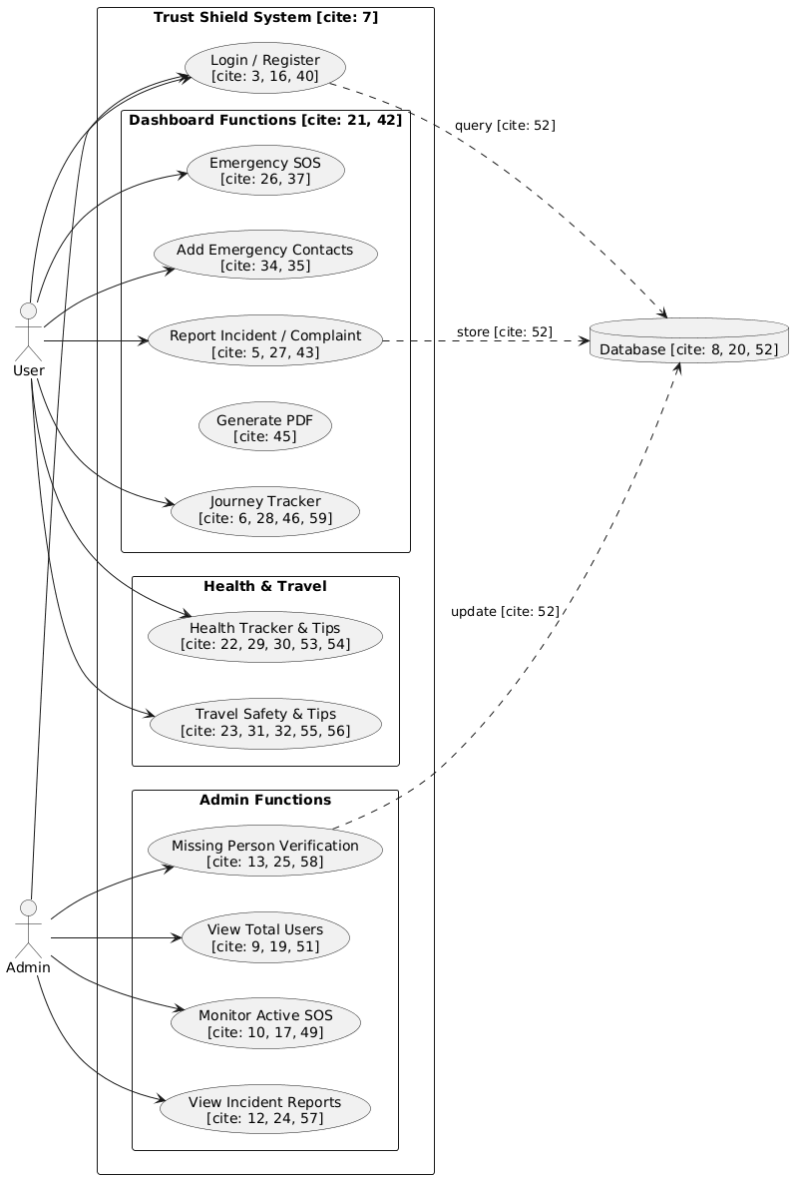
Use case diagram
Data flow diagram

Level-0

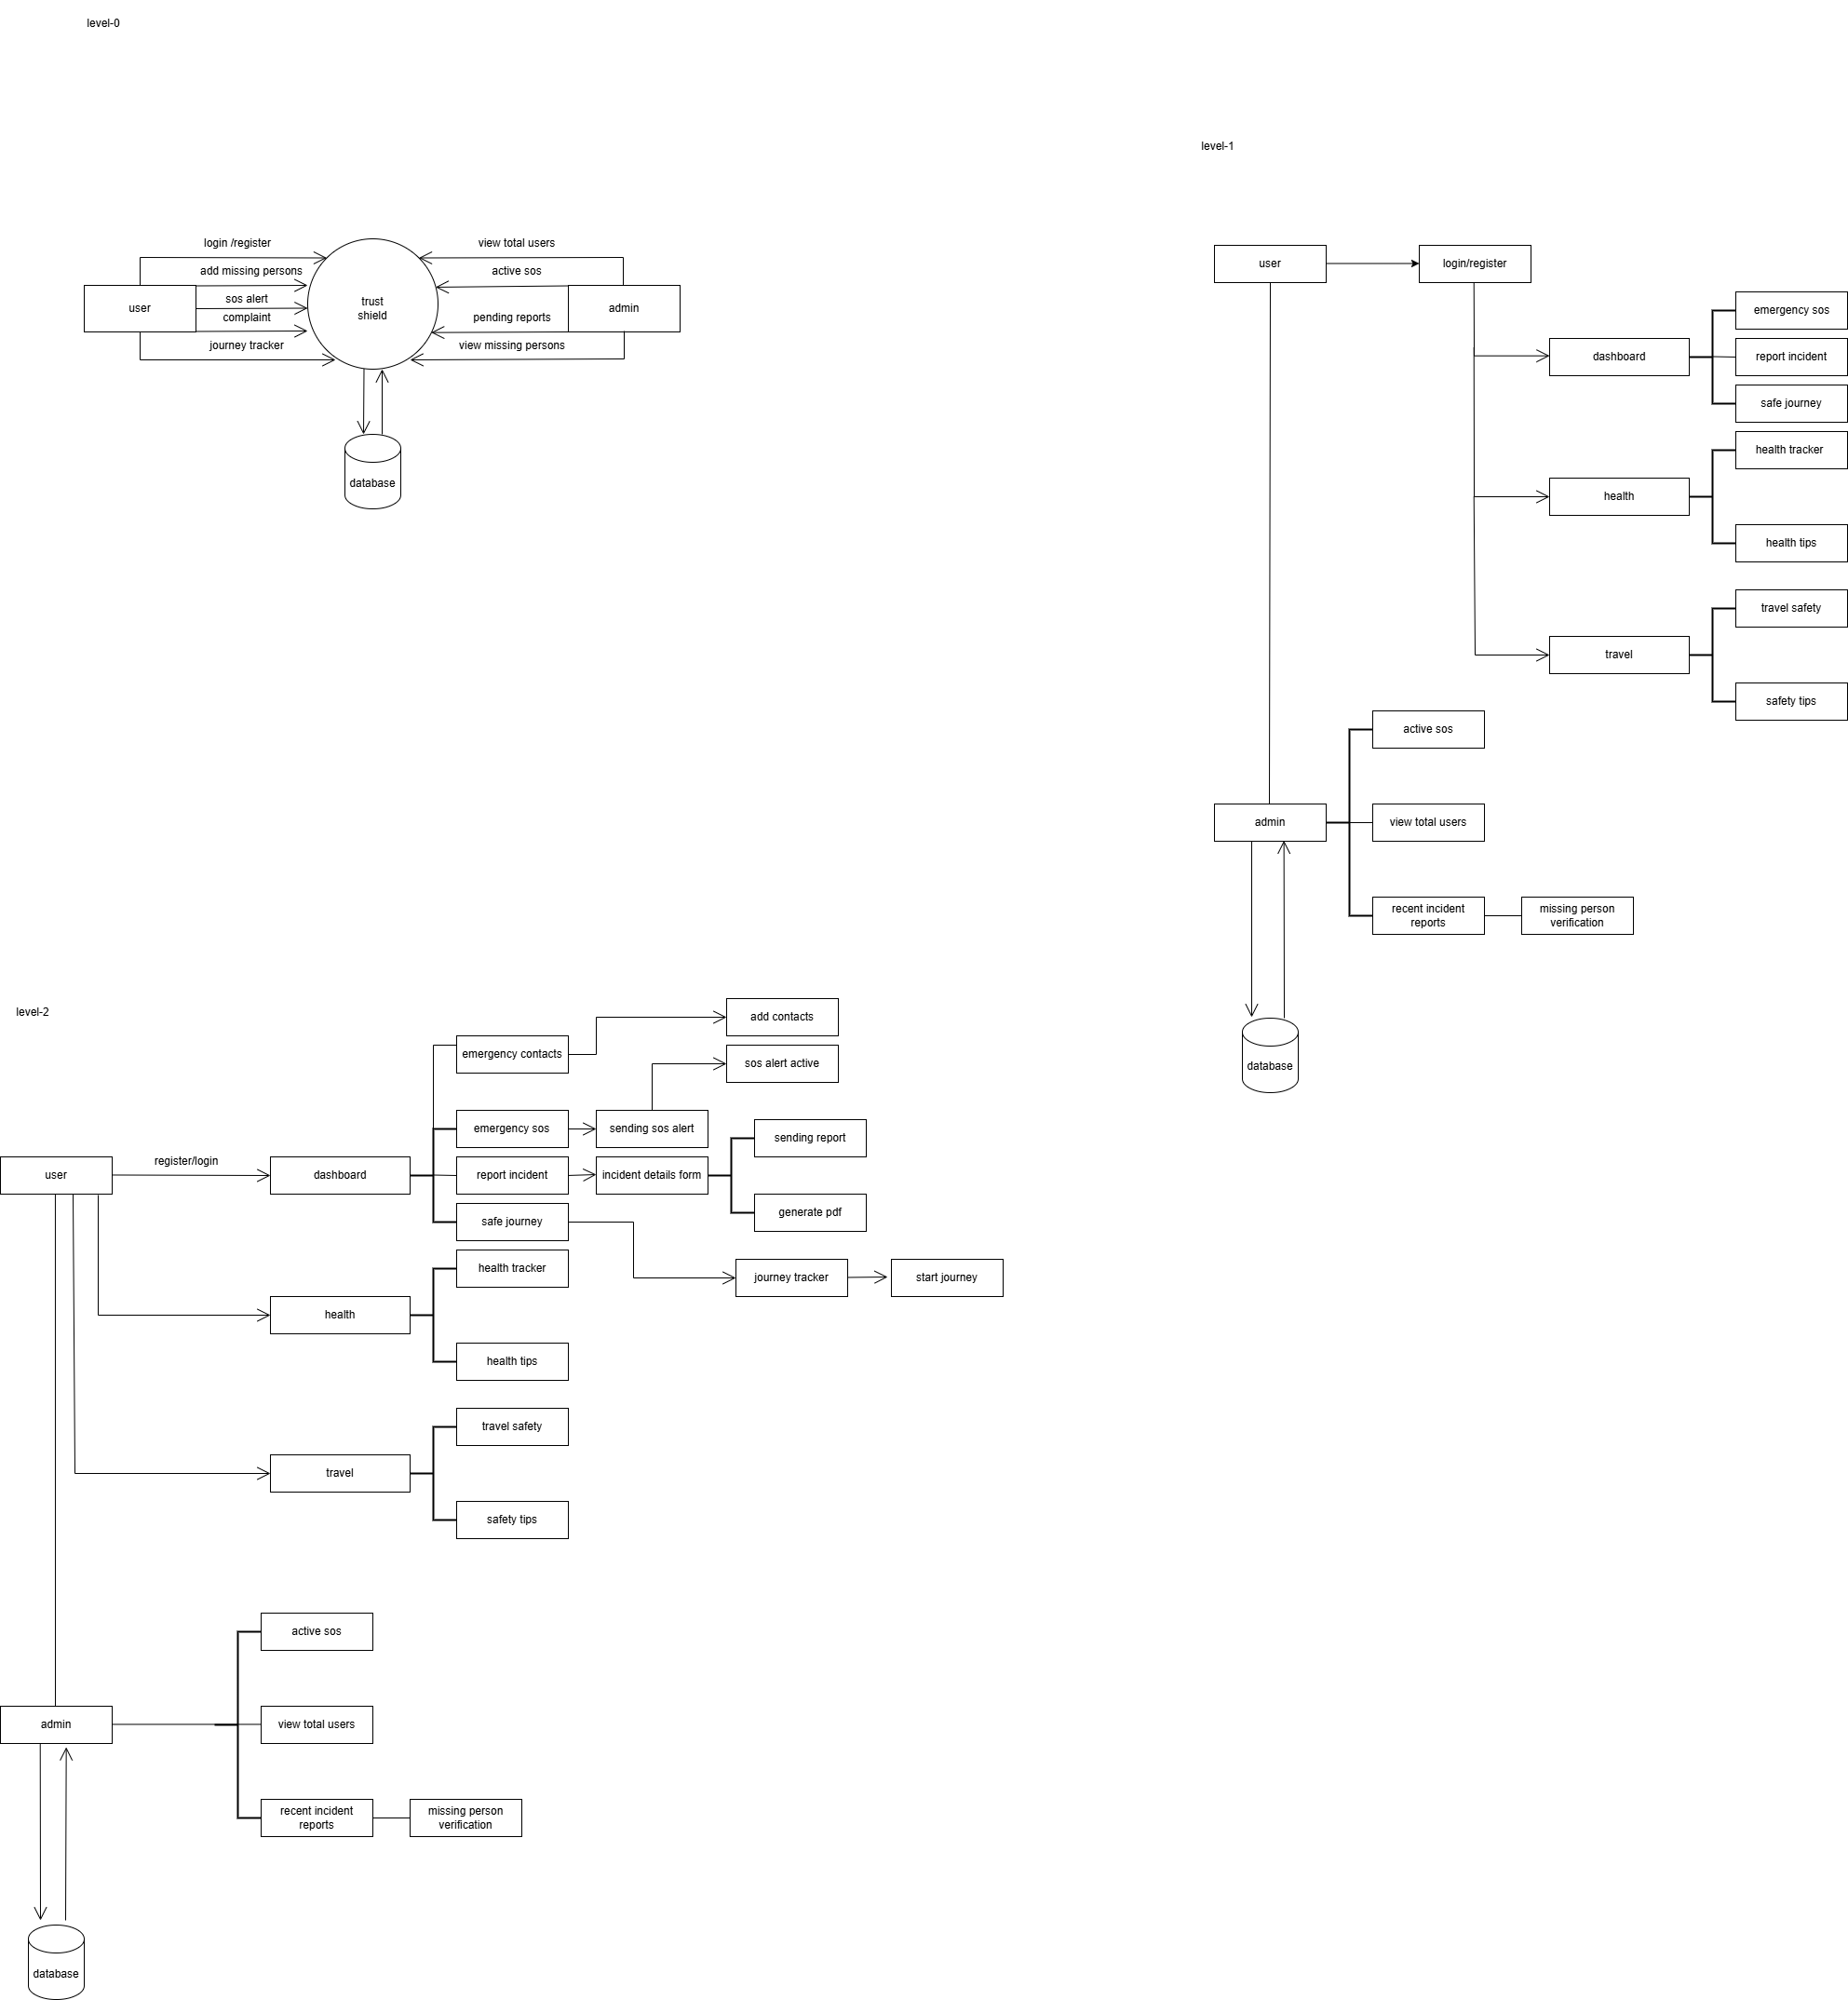

Level-1
user
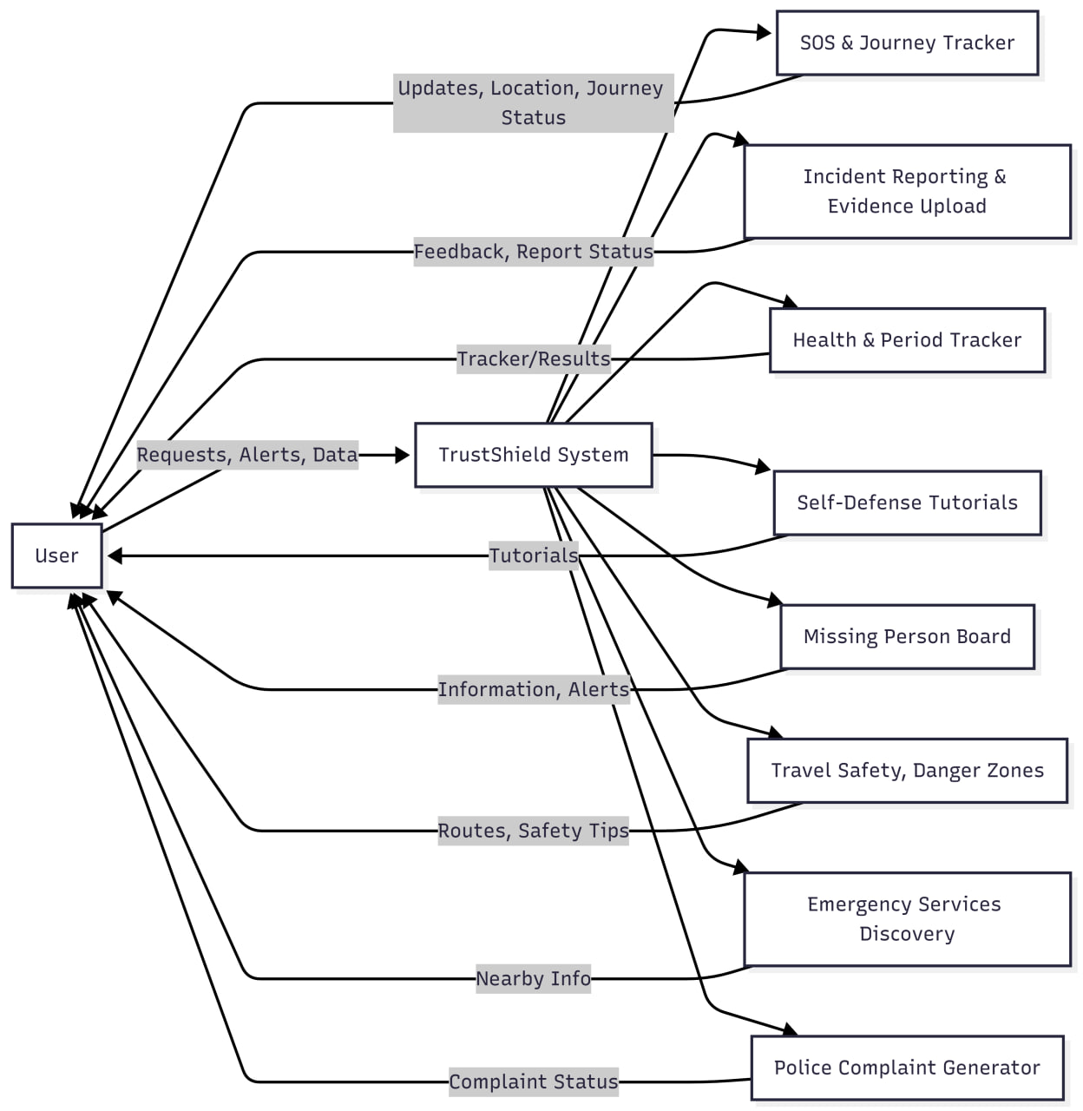

Admin
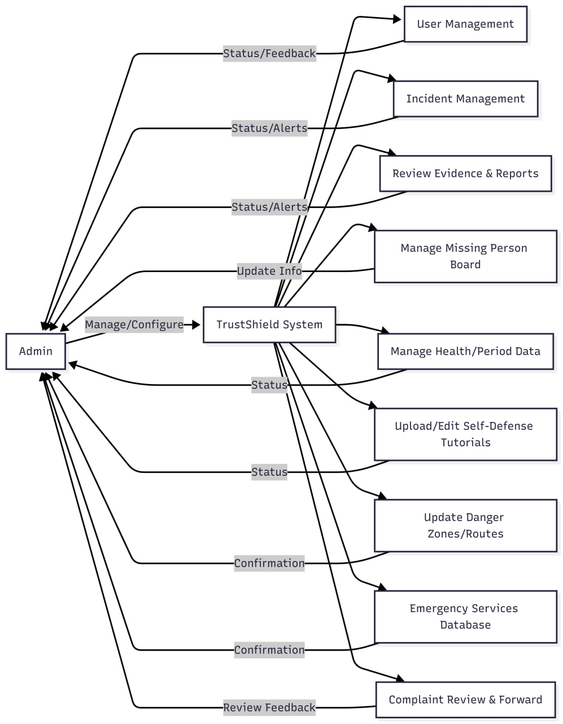
Level-2
User

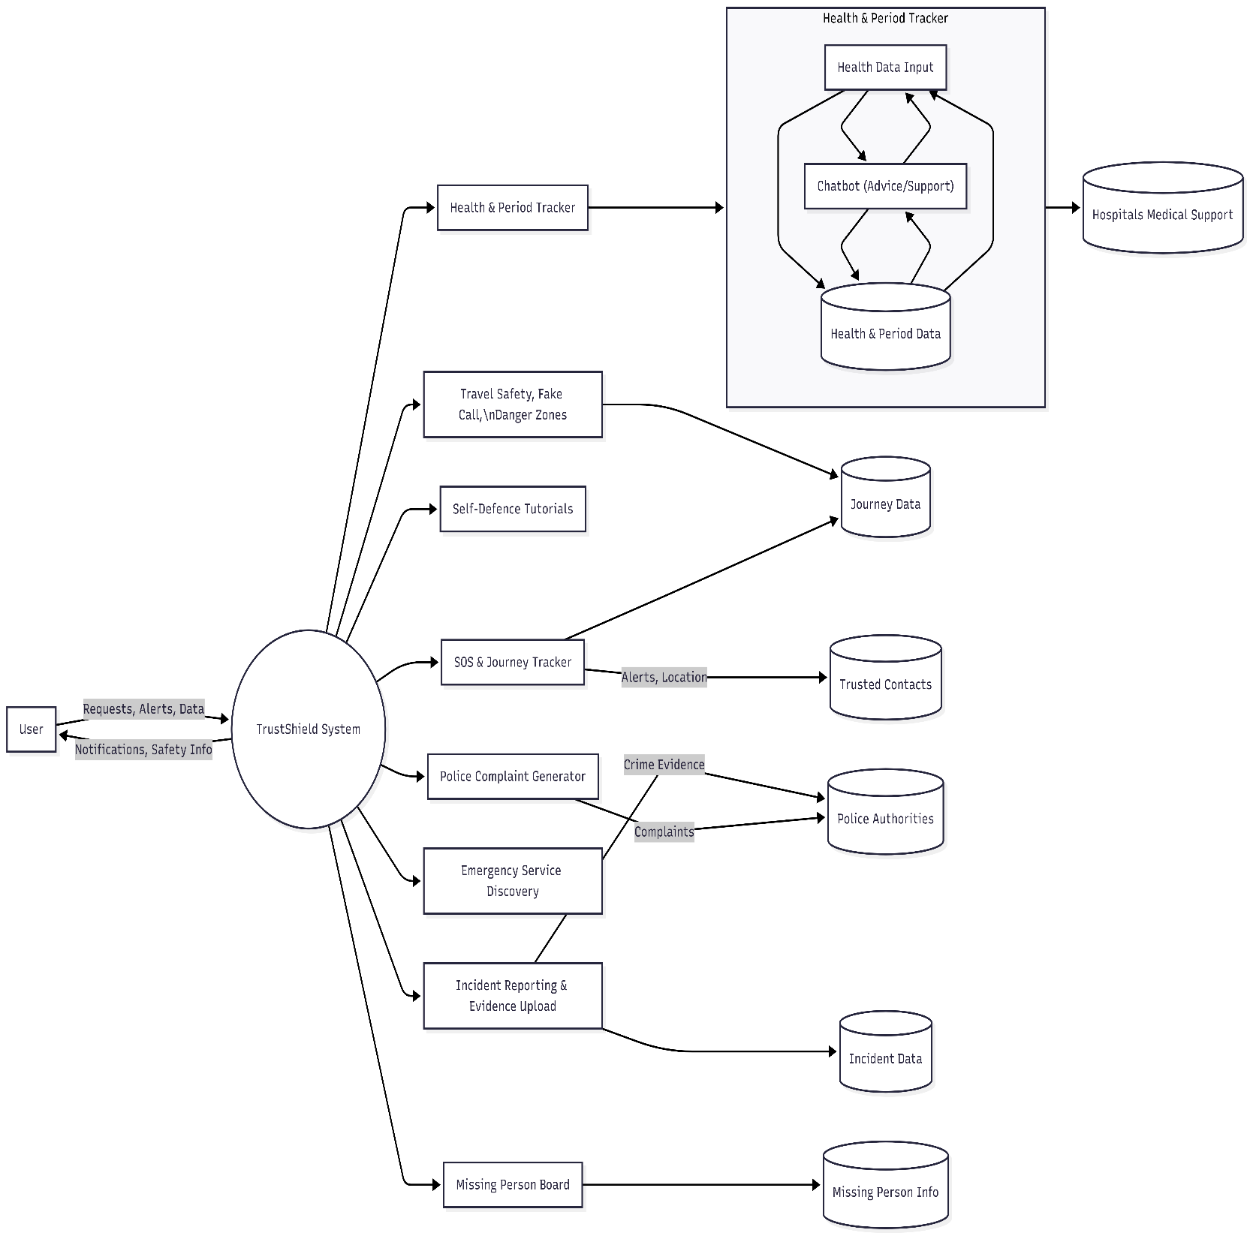
Admin
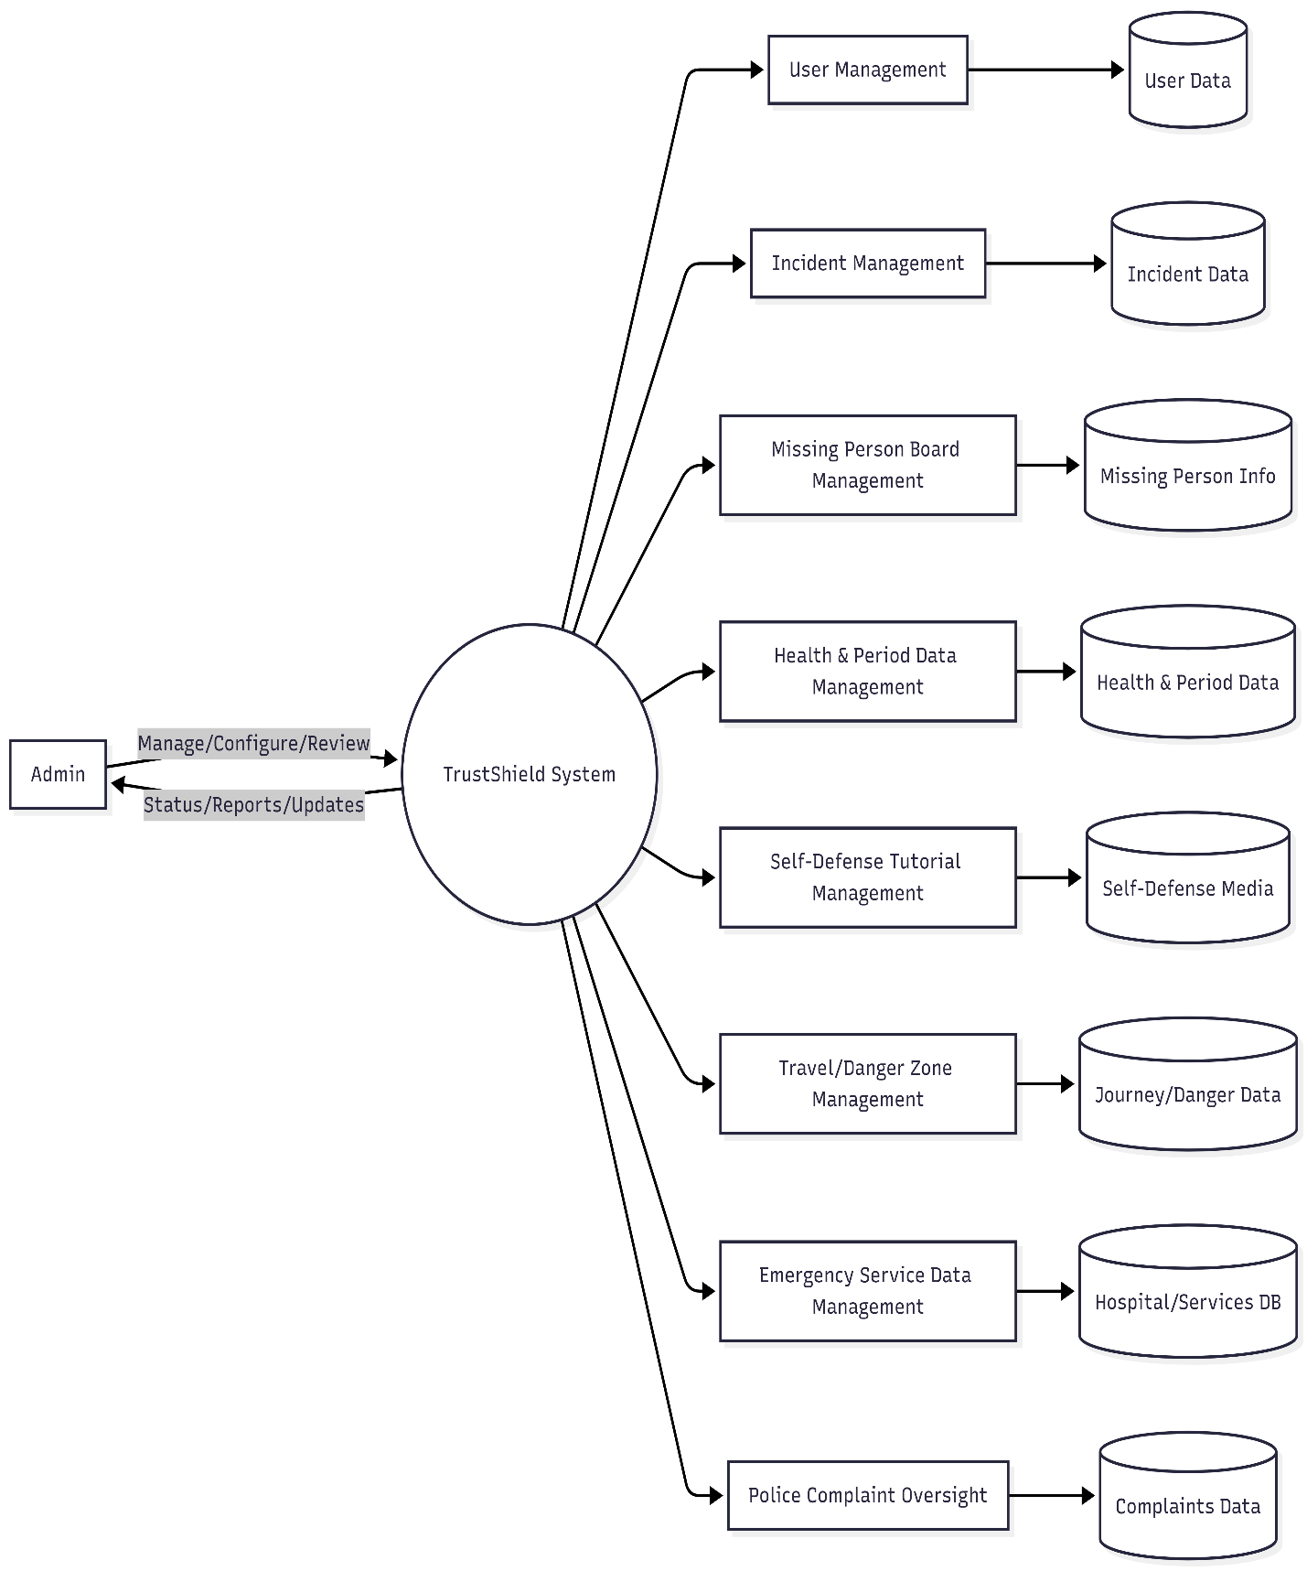

Input design
Input design in the Trust Shield system focuses on collecting accurate, secure, and user-friendly data required for effective safety and emergency assistance. The system provides structured input forms that allow users to enter essential information such as personal details, emergency contact numbers, and health-related data during registration. All input fields are designed with proper validation to ensure correctness, such as valid phone numbers, required fields, and appropriate data formats.
During emergency situations, the system allows users to provide inputs through simple and quick interfaces like the one-click SOS button and quick incident reporting forms. Location data is automatically captured using GPS services to avoid manual entry and reduce errors. For incident reporting, users can input details such as incident type, date, time, and description, along with the option to upload supporting evidence in the form of images, videos, or audio recordings.
The input design also supports features like journey tracking, where travel start and end points are entered or selected through map interfaces, and fake call activation, which requires minimal user interaction. Health and period tracking inputs are designed to be simple and private, allowing users to record information easily without complexity.
Overall, the input design of Trust Shield emphasizes simplicity, speed, and accuracy to ensure that users can interact with the system effectively, especially during critical emergency situations, while maintaining data security and integrity.

Output design

The output design of the Trust Shield system focuses on presenting safety-related information clearly, accurately, and in real time to support quick decision-making during emergencies. The system outputs critical alerts, notifications, and location details in a simple and understandable format so that users and emergency contacts can respond immediately.
When an SOS alert is triggered, the system displays confirmation messages to the user and sends alert notifications containing real-time location details to trusted contacts. Journey tracking outputs include live route maps, travel status updates, and alerts in case of route deviation or inactivity. The system also displays safe route suggestions and danger zone maps visually using map interfaces to help users choose safer paths.
For incident and crime reporting, the system generates structured outputs such as incident summaries, status updates, and downloadable police complaint documents in PDF format. Uploaded evidence is displayed securely with proper access control. Outputs related to nearby hospitals and police stations are shown as location-based lists and map markers for easy navigation.
Administrative outputs include user activity reports, incident records, and missing person details, which help authorities or administrators monitor and manage safety-related data effectively. Overall, the output design ensures that all information is presented in a timely, user-friendly, and visually clear manner, improving response efficiency and overall system usability.

Database design and Tables

The database design of the Trust Shield system is structured to store, manage, and retrieve safety-related data efficiently and securely. The database plays a critical role in maintaining user information, emergency contacts, incident records, location logs, and evidence files. A relational or NoSQL database can be used depending on scalability and performance requirements.
The user database stores essential information such as user identification details, login credentials, contact information, and health-related data. Emergency contact details are stored in a separate structure and linked to the user profile to allow quick retrieval during SOS situations. Location data generated during journey tracking and emergency alerts is stored with timestamps to support real-time monitoring and future analysis.
Incident and crime report data includes incident type, description, date, time, and location, along with references to uploaded evidence files. Evidence such as images, videos, and audio recordings are stored securely either in the database or in dedicated storage with database references. The system also maintains records for police complaint documents, missing person information, and alert history.
Administrative data is stored separately to manage system users, reported incidents, and platform activity. The database is designed with proper indexing and relationships to ensure fast access, data integrity, and scalability. Security measures such as access control, encryption, and regular backups are considered to protect sensitive user data and ensure system reliability.

users

Attribute Name | Data Type | Description | Constraints
id | STRING | Document ID | PRIMARY KEY
uid | STRING | User unique identifier | NOT NULL
name | STRING | Full name | NOT NULL
email | STRING(150) | Login email | UNIQUE, NOT NULL
password | STRING(255) | User password | NOT NULL
emergency_contacts | ARRAY | Contact objects array | -
created_at | TIMESTAMP | Account creation time | DEFAULT NOW

sos_alerts

Attribute Name | Data Type | Description | Constraints
id | STRING | Document ID | PRIMARY KEY
uid | STRING | User ID | NOT NULL
lat | FLOAT | Latitude coordinate | -
lon | FLOAT | Longitude coordinate | -
time | TIMESTAMP | Alert timestamp | DEFAULT NOW
active | BOOLEAN | Alert status | -

incident_reports

Attribute Name | Data Type | Description | Constraints
id | STRING | Document ID | PRIMARY KEY
uid | STRING | Reporter user ID | -
incident_type | STRING | Incident category | -
description | STRING | Incident details | -
date | STRING | Incident date | -
time | STRING | Incident time | -
location | STRING | Incident location | -
anonymous | BOOLEAN | Anonymous flag | -
evidence | STRING | Evidence file path | -
created | TIMESTAMP | Report creation time | DEFAULT NOW

missing_persons

Attribute Name | Data Type | Description | Constraints
id | STRING | Document ID | PRIMARY KEY
reporter_uid | STRING | Reporter user ID | -
name | STRING | Missing person name | NOT NULL
age | STRING | Age | -
gender | STRING | Gender | -
last_seen_place | STRING | Last seen location | -
last_seen_date | STRING | Last seen date | -
contact_guardian | STRING | Guardian contact | -
description | STRING | Additional details | -
status | STRING | Case status | DEFAULT 'Missing'
case_id | STRING | Unique case ID | -
created_at | TIMESTAMP | Report timestamp | DEFAULT NOW

danger_zones

Attribute Name | Data Type | Description | Constraints
id | STRING | Document ID | PRIMARY KEY
name | STRING | Zone name | NOT NULL
category | STRING | Danger category | -
risk | STRING | Risk level | -
latitude | FLOAT | Latitude | -
longitude | FLOAT | Longitude | -
created_at | TIMESTAMP | Zone creation time | DEFAULT NOW

journeys

Attribute Name | Data Type | Description | Constraints
id | STRING | Document ID | PRIMARY KEY
destination | STRING | Journey destination | -
start_time | TIMESTAMP | Journey start time | DEFAULT NOW
status | STRING | Journey status | DEFAULT 'in_progress'
start_lat | FLOAT | Start latitude | -
start_lon | FLOAT | Start longitude | -

police_complaints

Attribute Name | Data Type | Description | Constraints
id | STRING | Document ID | PRIMARY KEY
fir_number | STRING | FIR number | -
station | STRING | Police station | -
district | STRING | District | -
incident_type | STRING | Incident category | -
details | STRING | Complaint details | -
date | STRING | Incident date | -
place | STRING | Incident location | -
created_at | TIMESTAMP | Complaint time | DEFAULT NOW

cycle_tracker

Attribute Name | Data Type | Description | Constraints
id | STRING | Document ID | PRIMARY KEY
last_date | STRING | Last cycle date | -
updated_at | TIMESTAMP | Last update time | DEFAULT NOW

admin

S.No | Attribute Name | Data Type | Description | Constraints
1 | id | STRING | Document ID | PRIMARY KEY
2 | email | STRING(150) | Admin login email | UNIQUE, NOT NULL
3 | username | STRING(50) | Admin username | UNIQUE, NOT NULL
4 | password | STRING(255) | Hashed password (bcrypt) | NOT NULL
5 | name | STRING(100) | Admin full name | NOT NULL
6 | role | STRING(20) | Admin role/privilege level | DEFAULT 'admin'
7 | created_at | TIMESTAMP | Account creation timestamp | DEFAULT CURRENT_TIMESTAMP
8 | last_login | TIMESTAMP | Last login timestamp | Optional
9 | is_active | BOOLEAN | Account active status | DEFAULT true

Testing Methodology and Strategies

The Trust Shield system follows a systematic testing methodology to ensure that all safety features function correctly, reliably, and securely. Testing is performed at different stages of development to identify errors early and to verify that the system meets the specified requirements. Both manual and automated testing approaches are used to validate the functionality and performance of the application.
Unit testing is carried out to verify individual modules such as user authentication, SOS alert triggering, location fetching, and incident reporting. Each function is tested independently to ensure correct input handling and expected output generation. Integration testing is then performed to check the interaction between different modules, such as communication between the frontend and backend, database operations, and third-party services like map and notification APIs.
System testing is conducted to evaluate the complete application as a whole. This ensures that workflows such as emergency alert activation, journey tracking, evidence upload, and police complaint generation work smoothly in real-time scenarios. User interface testing is also performed to verify usability, responsiveness, and accessibility across different devices and browsers.
Security testing is an important part of the strategy to ensure that user data, location information, and evidence files are protected from unauthorized access. Performance testing is conducted to verify that the system responds quickly during high usage, especially during emergency alert situations. Finally, user acceptance testing is carried out to confirm that the system meets user expectations and is easy to use in real-life emergency conditions.
Overall, the testing methodology ensures system reliability, accuracy, security, and readiness for real-world deployment.

Black Box Testing Overview

Black box testing is used in the Trust Shield project to verify the system’s functionality without considering the internal code structure. In this approach, the application is tested from the user’s perspective to ensure that all features work as expected based on given inputs. Functionalities such as user registration, login, SOS alert activation, live location sharing, journey tracking, incident reporting, and evidence upload are tested by providing valid and invalid inputs and observing the outputs. This testing ensures that the system meets user requirements, displays correct messages, sends alerts properly, and handles errors gracefully during real-world usage.

White Box Testing Overview

White box testing is applied to examine the internal logic, code structure, and execution flow of the Trust Shield system. This testing focuses on verifying backend logic such as SOS alert processing, database interactions, location data handling, notification triggering, and PDF complaint generation. Control structures, conditional statements, loops, and API integrations are tested to ensure correct execution paths and data flow. White box testing helps identify logical errors, security vulnerabilities, and performance issues within the code, ensuring that the internal working of the system is reliable and efficient.

Unit testing Overview

Unit testing in the Trust Shield project involves testing individual components or modules independently to ensure they function correctly. Each module, such as user authentication, emergency contact management, SOS alert service, journey tracker, incident reporting module, and notification service, is tested separately. By isolating each unit, errors can be identified and fixed early in the development process. Unit testing improves code quality, reduces system-level failures, and ensures that each component performs as intended before integration with other modules.

Conclusion
The Trust Shield – Safety & Smart Emergency Assistance Website is designed to address the growing need for reliable personal safety solutions in today’s fast-paced and unpredictable environments. The system combines essential safety features such as one-click SOS alerts, real-time location sharing, journey tracking, and quick incident reporting into a single, user-friendly web platform. By enabling instant communication with trusted contacts and providing access to nearby emergency services, Trust Shield significantly reduces response time during critical situations.
The project also emphasizes preventive and supportive safety measures through features like safe route guidance, danger zone identification, evidence upload, and police complaint generation. These functionalities help users not only during emergencies but also in preparing for and avoiding unsafe situations. With secure data handling, scalable architecture, and scope for future AI/ML integration, Trust Shield proves to be an effective, practical, and reliable digital safety companion that can contribute to improving personal safety and emergency management in real-life scenarios.

